[A - Print Many Hello World](https://vjudge.net/problem/Aizu-ITP1_3_A" \t "_blank)

 #include<bits/stdc++.h>

using namespace std;

int main()

{

for(int i=1;i<=1000;i++)

{

cout<<"Hello World"<<"\n";

}

}

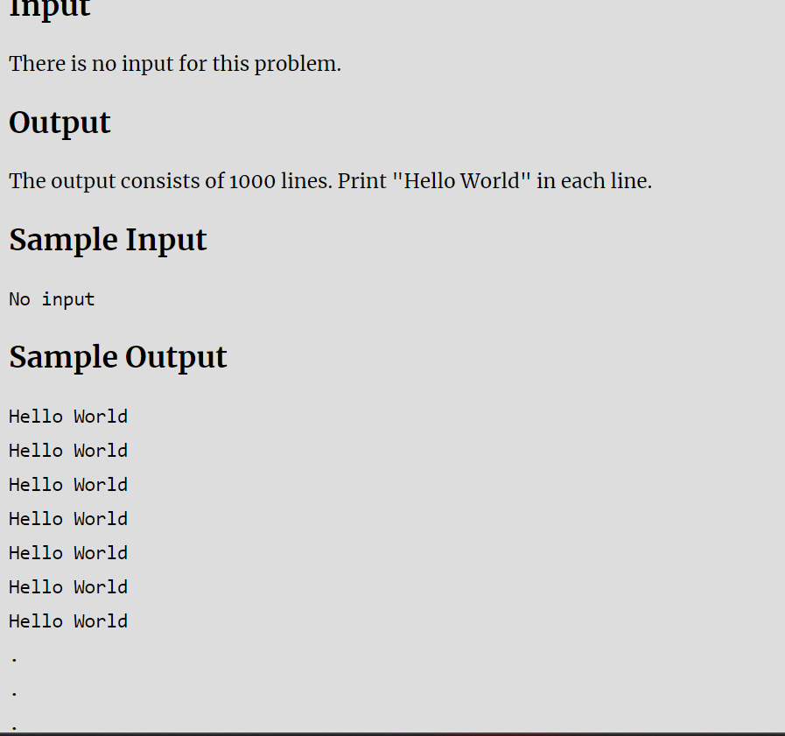

[B - The missing number](https://vjudge.net/problem/HackerRank-si-basic-the-missing-number)

#include<bits/stdc++.h>

using namespace std;

int main()

{

int sum=0;

int a;

for(int i=1;i<100;i++)

{

cin>>a;

sum+=a;

}

cout<<5050-sum;

}

12 15 9 1 71 77 81 29 70 19 11 83 56 2 57 53 68 99 82 100 22 10 51 40 34 98 80 38 39 89 94 4 26 64 45 8 90 24 93 33 21 7 49 88 5 28 55 67 65 50 32 58 6 37 46 42 20 44 41 3 78 76 73 16 31 85 91 54 60 47 97 43 84 17 35 69 13 30 61 79 72 48 23 66 52 27 62 87 63 18 75 96 14 86 95 74 25 59 36

//92

[C - Number reverse](https://vjudge.net/problem/HackerRank-si-basic-number-reverse)

 #include<bits/stdc++.h>

using namespace std;

int main()

{

int rem,rev,n;

cin>>n;

while(n!=0)

{

rem=n%10;

rev=rev\*10+rem;

n=n/10;

}

cout<<rev<<"\n";

}

1433

//3341

[D - Compute N!](https://vjudge.net/problem/HackerRank-si-basic-compute-n)

 #include<bits/stdc++.h>

using namespace std;

int main()

{

int fact=1;

int n;

cin>>n;

for(int i=1;i<=n;i++)

{

fact\*=i;

}

cout<<fact<<"\n";

}

//5

120

[E - Natural numbers sum](https://vjudge.net/problem/HackerRank-si-basic-natural-numbers-sum)

 #include<bits/stdc++.h>

using namespace std;

int main()

{

int n;

cin>>n;

int sum=0;

for(int i=1;i<=n;i++)

{

sum+=i;

}

cout<<sum<<"\n";

}

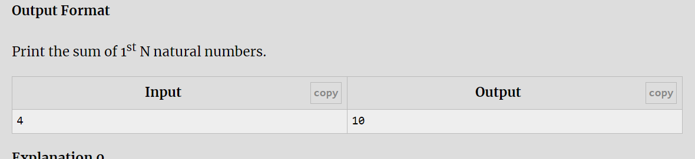

[F - Squares sum](https://vjudge.net/problem/HackerRank-si-basic-squares-sum)

 #include<bits/stdc++.h>

using namespace std;

int main()

{

int n;

cin>>n;

int sum;

for(int i=1;i<=n;i++)

{

sum=n\*(n+1)\*(2\*n+1)/6;

}

cout<<sum<<"\n";

}

//15

1240

[G - Cubes sum](https://vjudge.net/problem/HackerRank-si-basic-cubes-sum)

 #include<bits/stdc++.h>

using namespace std;

int main()

{

int n;

cin>>n;

int sum;

for(int i=1;i<=n;i++)

{

sum=(i\*i\*i)+sum;

}

cout<<sum<<"\n";

}

//4

100

[H - Compute a power b.](https://vjudge.net/problem/HackerRank-si-basic-compute-a-power-b)

 #include<bits/stdc++.h>

using namespace std;

int main()

{

int a,b;

cin>>a>>b;

int result=pow(a,b);

cout<<result<<"\n";

}

2 3

//8

[I - Compute fibonacci number](https://vjudge.net/problem/HackerRank-si-basic-compute-fibonacci-number)

 #include<bits/stdc++.h>

using namespace std;

int main()

{

int a=0,b=1,c=1;

int n;

cin>>n;

for(int i=1;i<n;i++)

{

c=a+b;

a=b;

b=c;

}

cout<<c;

}

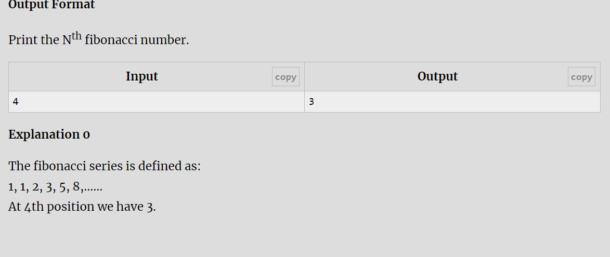

[J - Check Armstrong number](https://vjudge.net/problem/HackerRank-si-basic-check-armstrong-number)

#include<bits/stdc++.h>

using namespace std;

int main()

{

int n,n1,rem,sum=0;

cin>>n;

n1=n;

while(n>0)

{

rem=n%10;

sum=(rem\*rem\*rem)+sum;

n=n/10;

}

if(n1==sum)

{

cout<<"Yes"<<"\n";

}

else

{

cout<<"No"<<"\n";

}

}

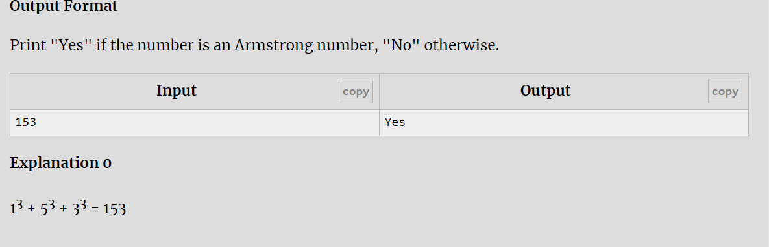

## [K - Narcissistic numbers](https://vjudge.net/problem/HackerRank-si-basic-narcissistic-numbers)

//K - Narcissistic numbers

#include <bits/stdc++.h>

using namespace std;

int main()

{

int n,n1,rem,result=0,temp,count=0;

cin>>n;

temp=n;

while(n!=0)

{

count++;

n=n/10;

}

temp=n;

while(n!=0)

{

rem=n%10;

result+=pow(rem,count);

n=n/10;

}

if(result==temp)

{

cout<<"Yes"<<"\n";

}

else

{

cout<<"No"<<"\n";

}

}

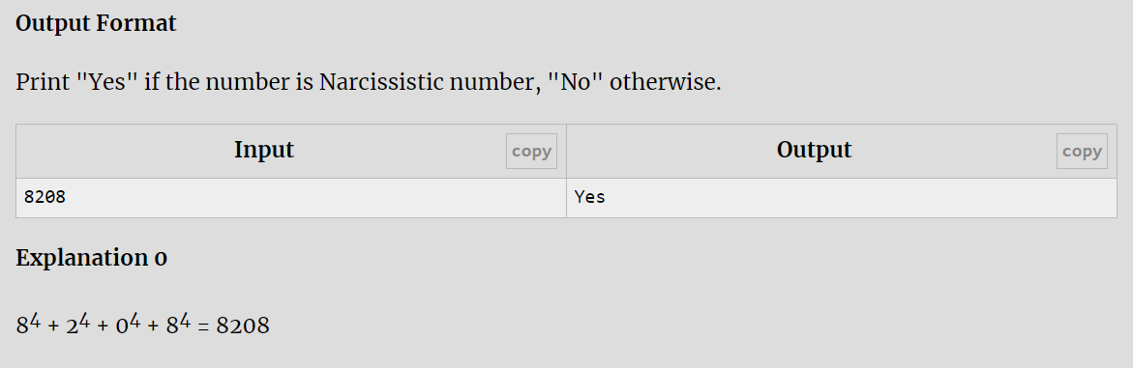

[L - Print Test Cases](https://vjudge.net/problem/Aizu-ITP1_3_B)

 #include<bits/stdc++.h>

using namespace std;

int main()

{

int x;

cin>>x;

int cn=1;

while(x!=0)

{

cout << "Case " << cn << ": " << x << endl;

cn++;

cin >> x;

}

}

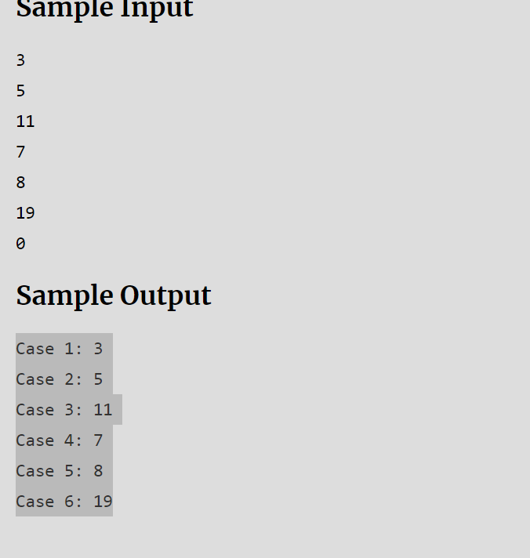

[M - How Many Divisors?](https://vjudge.net/problem/Aizu-ITP1_3_D)

 #include<bits/stdc++.h>

using namespace std;

int main()

{

int a,b,c;

cin>>a>>b>>c;

int count=0;

for(int i=a;i<=b;i++)

{

if(c%i==0)

{

count++;

}

}

cout<<count;

}

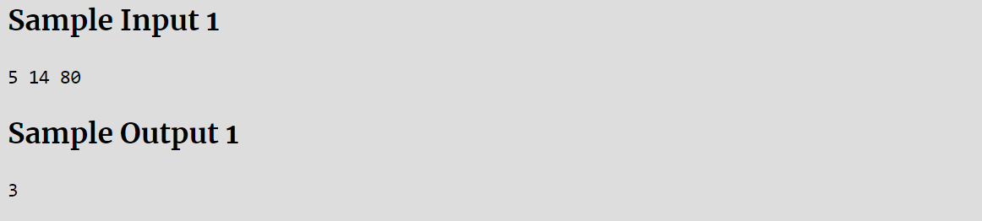

[N - Non-Negative Product](https://vjudge.net/problem/CodeChef-NONNEGPROD)

[O - Print multiplication table](https://vjudge.net/problem/HackerRank-si-basic-print-multiplication-table)

#include <bits/stdc++.h>

using namespace std;

int main()

{

int n;

cin>>n;

for(int i=1;i<=10;i++)

{

int res=n\*i;

cout<<n<<"\*"<<i<<"="<<res<<"\n";

}

}

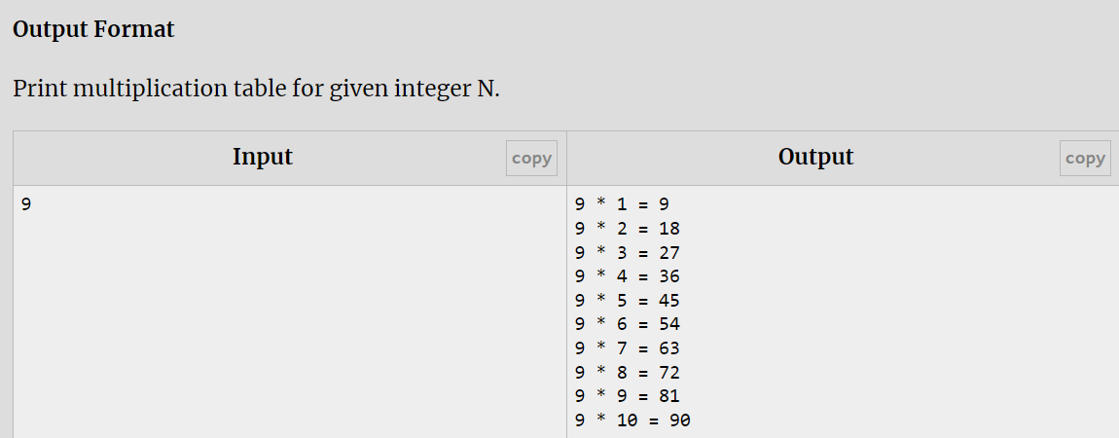

## [P - Number of multiples](https://vjudge.net/problem/HackerRank-si-basic-number-of-multiples)

 #include <bits/stdc++.h>

using namespace std;

int main()

{

int n;

int count=0;

cin>>n;

for(int i=1;i<=n;i++)

{

if(i%3==0 || i%5==0)

{

count++;

}

}

cout<<count;

}

